ModBus Protocol Specification
The Device’s ModBus protocol support ModBus RTU Mode, transport can be RS232, RS485 and RJ45 Netport. Please first check your PLC machine whether or not support RTU Mode.
The Device’s ModBus Protocol max support 12bytes card ID, if greater than 12bytes ID, please set reader’s read length less than 12bytes. Using readersoft, ParamSet->ByteLength


Step1: First Check your reader whether or not support ModBus, if not, contact your saler to get new hardware soft to upgrade it.
ModBus Settting in PLC
Set ModBus functionCode is 0x03 or 0x04, and read length is 7.
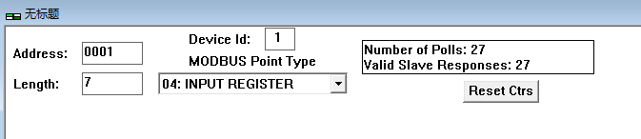
DeviceID is Reader’s RS485 address.
Then can get tag data from reader.
The data from reader is seven 16 bits binary data
Such as:
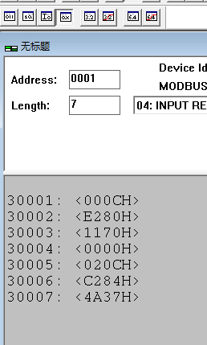
First 16 bits binary data mean tag length. Example: 000CH means tag length is 12 bytes, 0000H means no tag.
Last six 16 bits binary data means tag data, high byte first, together is total card ID.
As the picture show, the tag ID is E28011700000020CC2844A37

